## IIIT HYDERABAD SUMMER INTERNSHIP PROGRAM

**TASK SUBMISSION EXPLANATION**

**DATA PRISM**

**NAME : PAGADALA NAGENDRA** **EMAIL :** pagadalanagendra2003@gmail.com

**DATE :** 02/06/2023

## CONTENT

1. Backend( Python, Flask API)
   * Flask APIs
2. Uploading form
3. Uploading excels
4. Database collection(Mongo DB)
5. Connecting to Mongo DB
6. Frontend (React)
   * Mainpage
   * Form page
   * Form data visualization page
   * Excel page
   * Excel data visualization page

* Block diagram

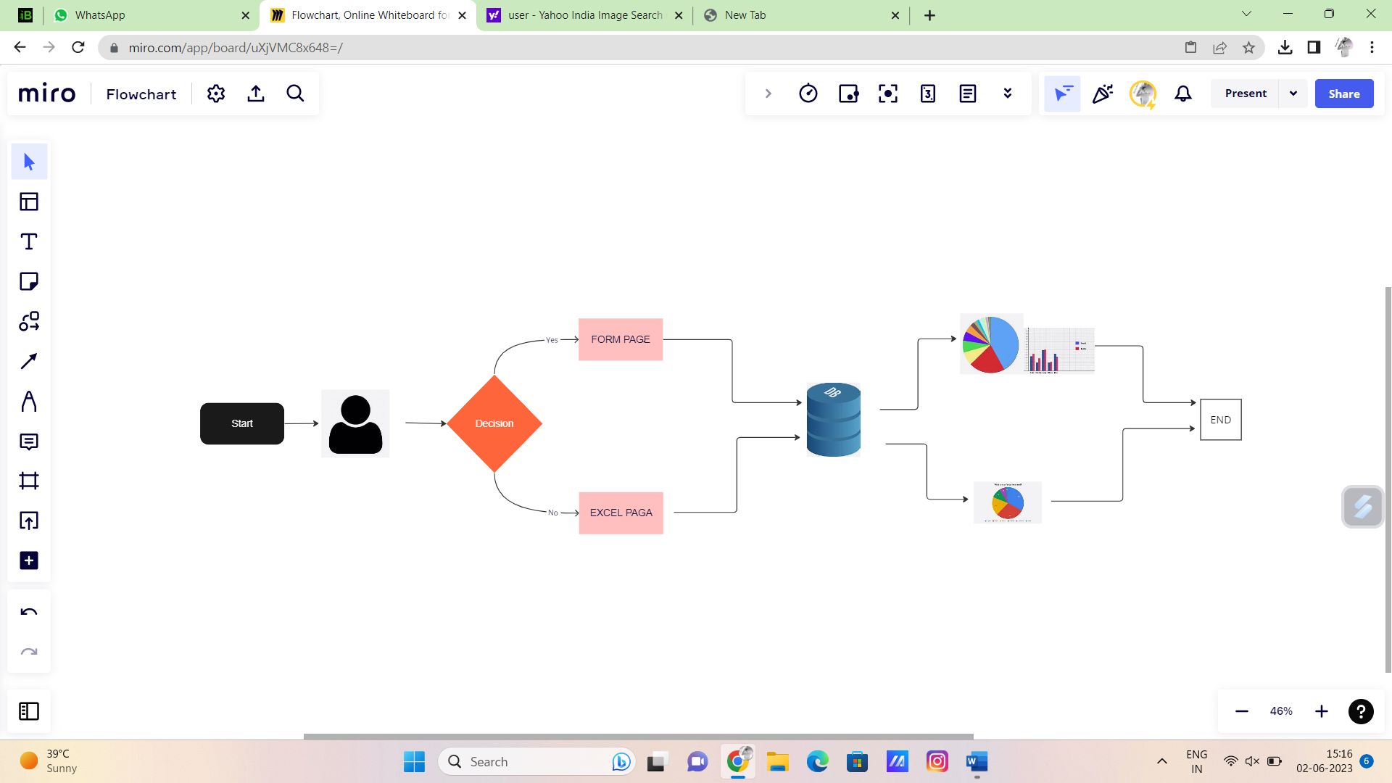

# Backend (Python, Flask API)

Flask APIs

* Uploading Form

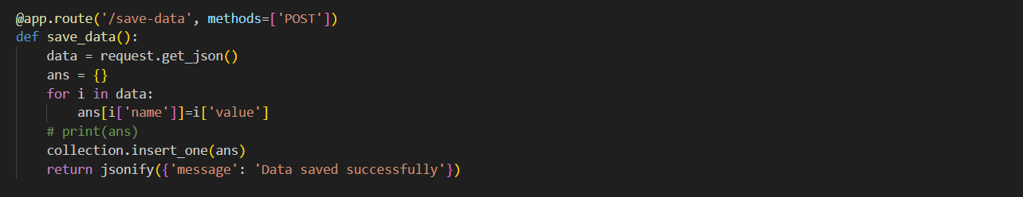

* Uploading excels

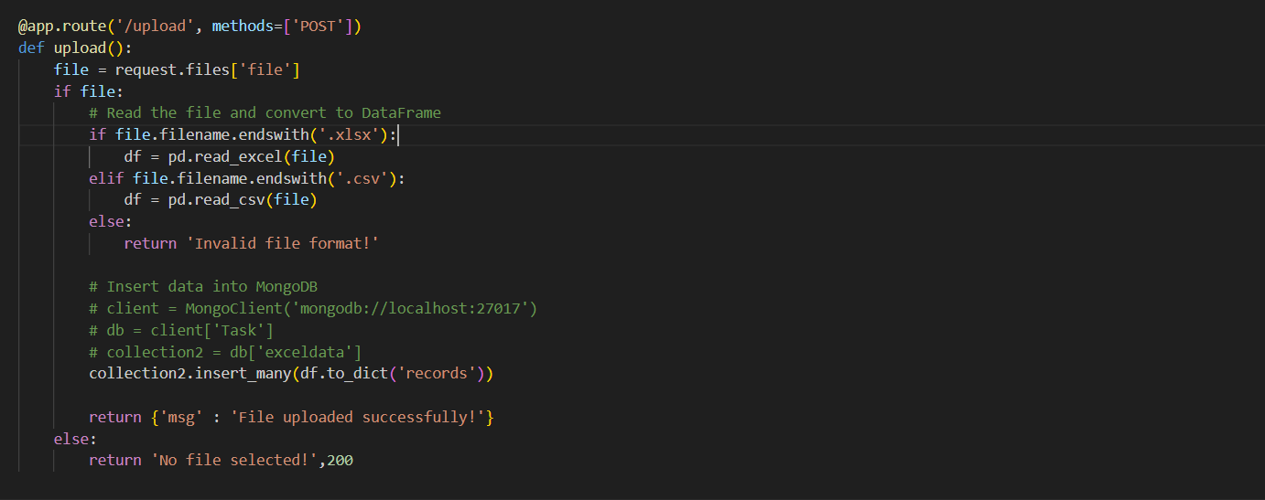

# Database collection(Mongo DB)

* Database in Mongo DB

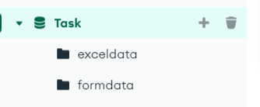

# Connecting to Mongo DB

* Linking Mongo DB in Backend(Flask)

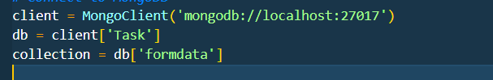

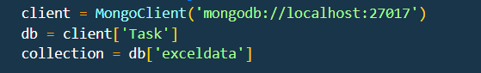

* By using pymongo we establish connection between MongoDB database and our application with DB name as “TASK” and collection name as “formdata & exceldata” in which only the form data is stored

# Frontend(React)

* Homepage & Form Submission page

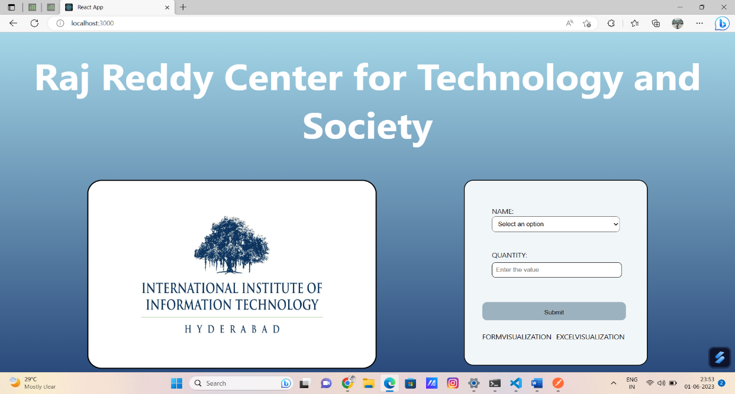

* Form Visualization

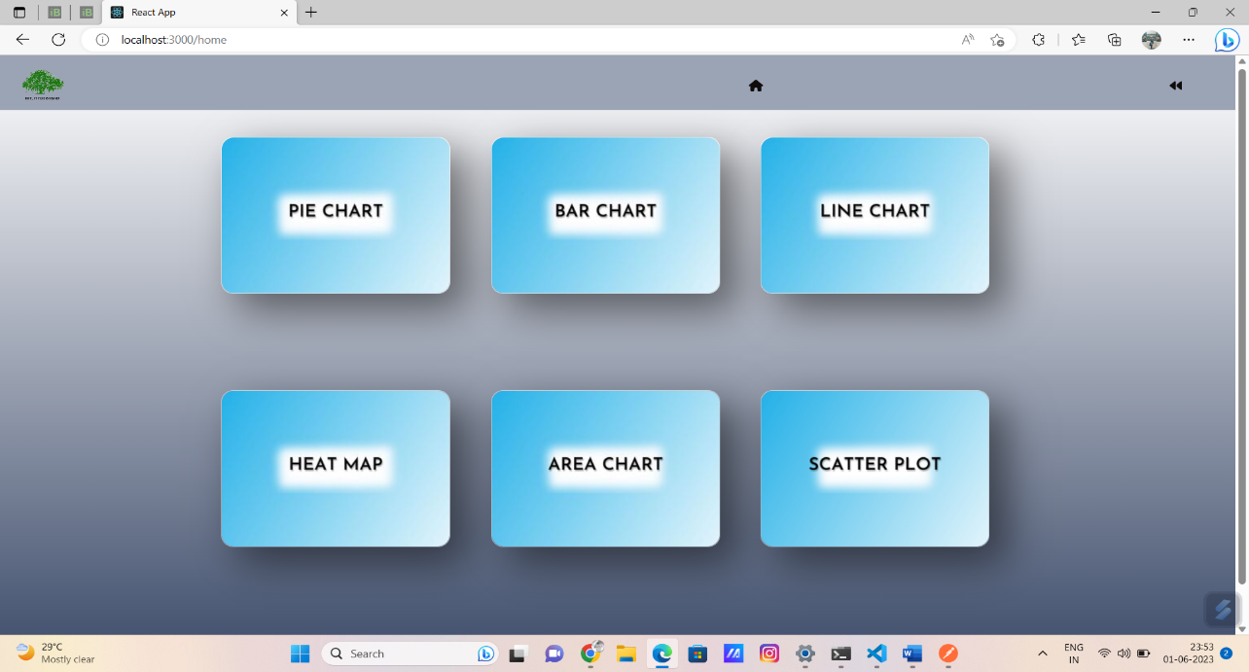 page

* Form details visualization page

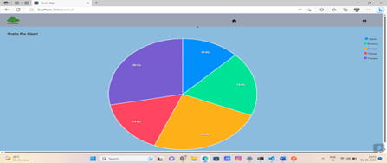

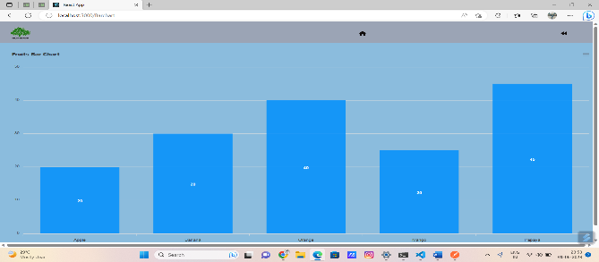

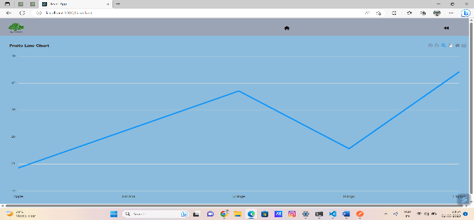

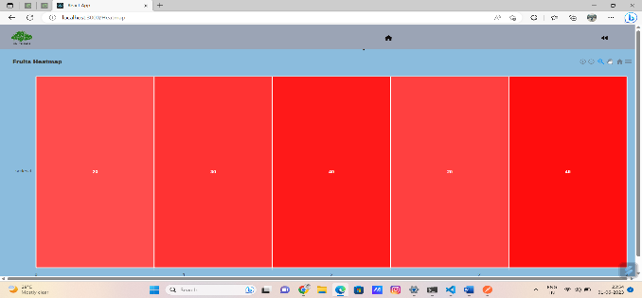

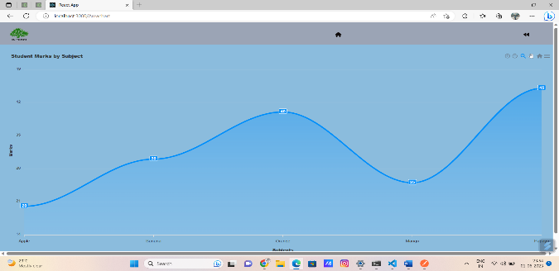

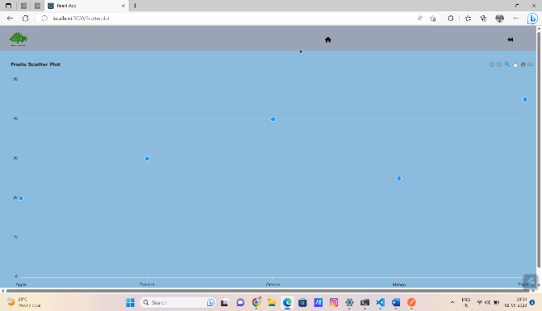

* Excel submission page

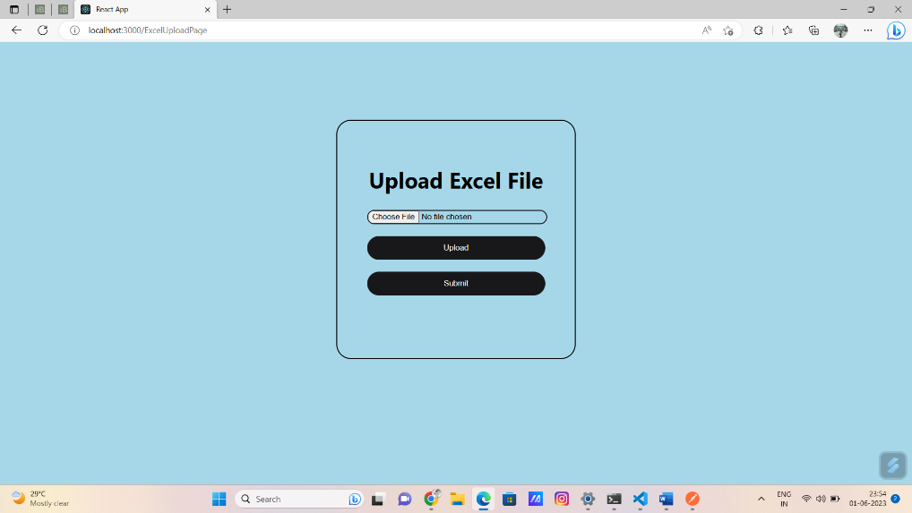

* Excel details visualization page

